ASSESSMENT 9

*“LIST SLICING, SETS, OPERATORS, LOOPS &, ELIF STATEMENTS”*



Submitted By

VAIBHAV PATIDAR

IPS ACADEMY, INDORE (M.P.)

**Date :** 14-12-2023

**Week 2** | **Day - 04**

**Conditional Statement :**

* These are the statements , which return true when the cndition written in parentheses of it is satisfied and then run the code written in the block.
* These are of different types, such as :

1. If statement
2. If-else statement
3. If elif statement
4. Nested if
5. Nested if-else
6. **Writing a Program to find the leap year using Nested if - else statements :**

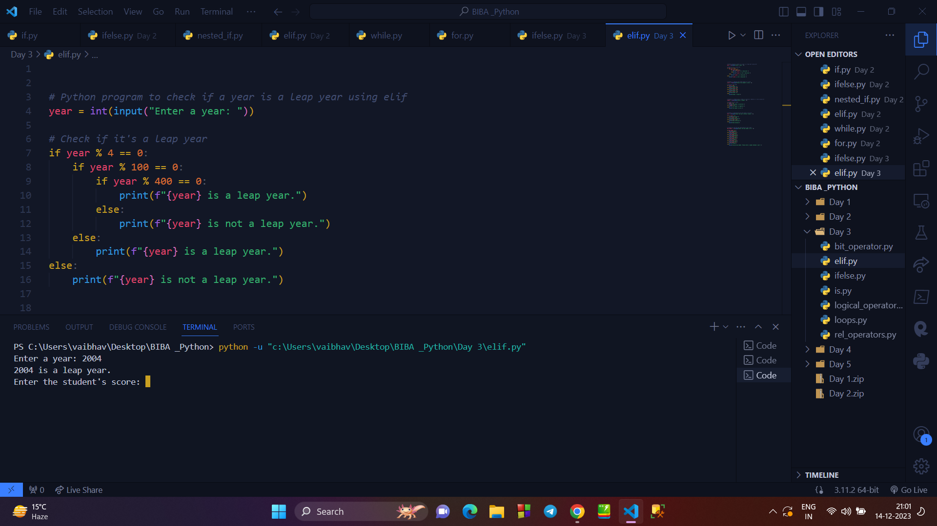

1. **Writing a program to display the day name based on user input using NESTED ELIF STATEMENT :**

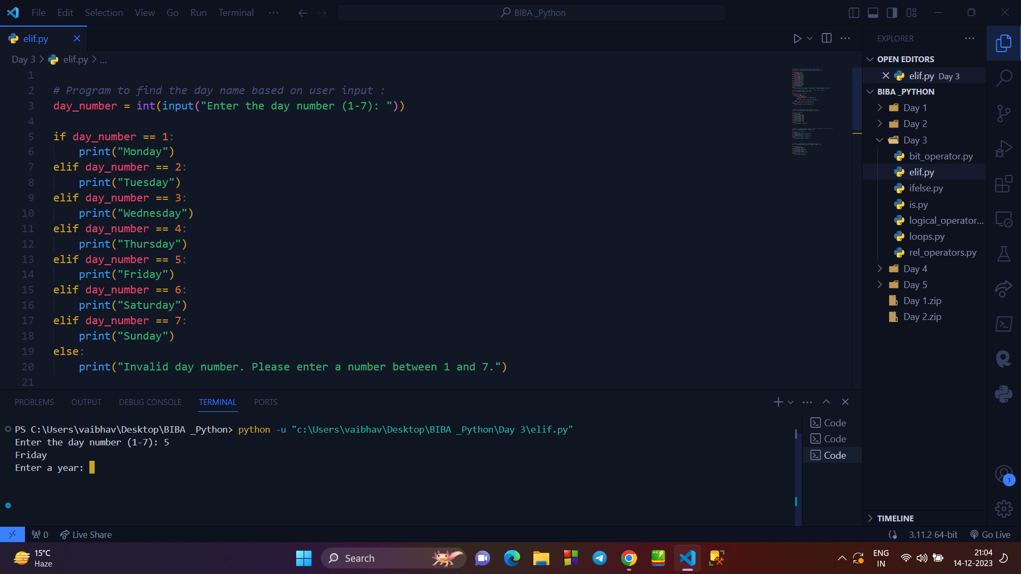

**→ RELATIONAL OPERATOR :**

* Relational operators are used to show the relation between different entities.
* There are mainly relational operators : < , > , <= , >= , == , !=

1. **Writing a program to display all the relational operator simultaneously :**

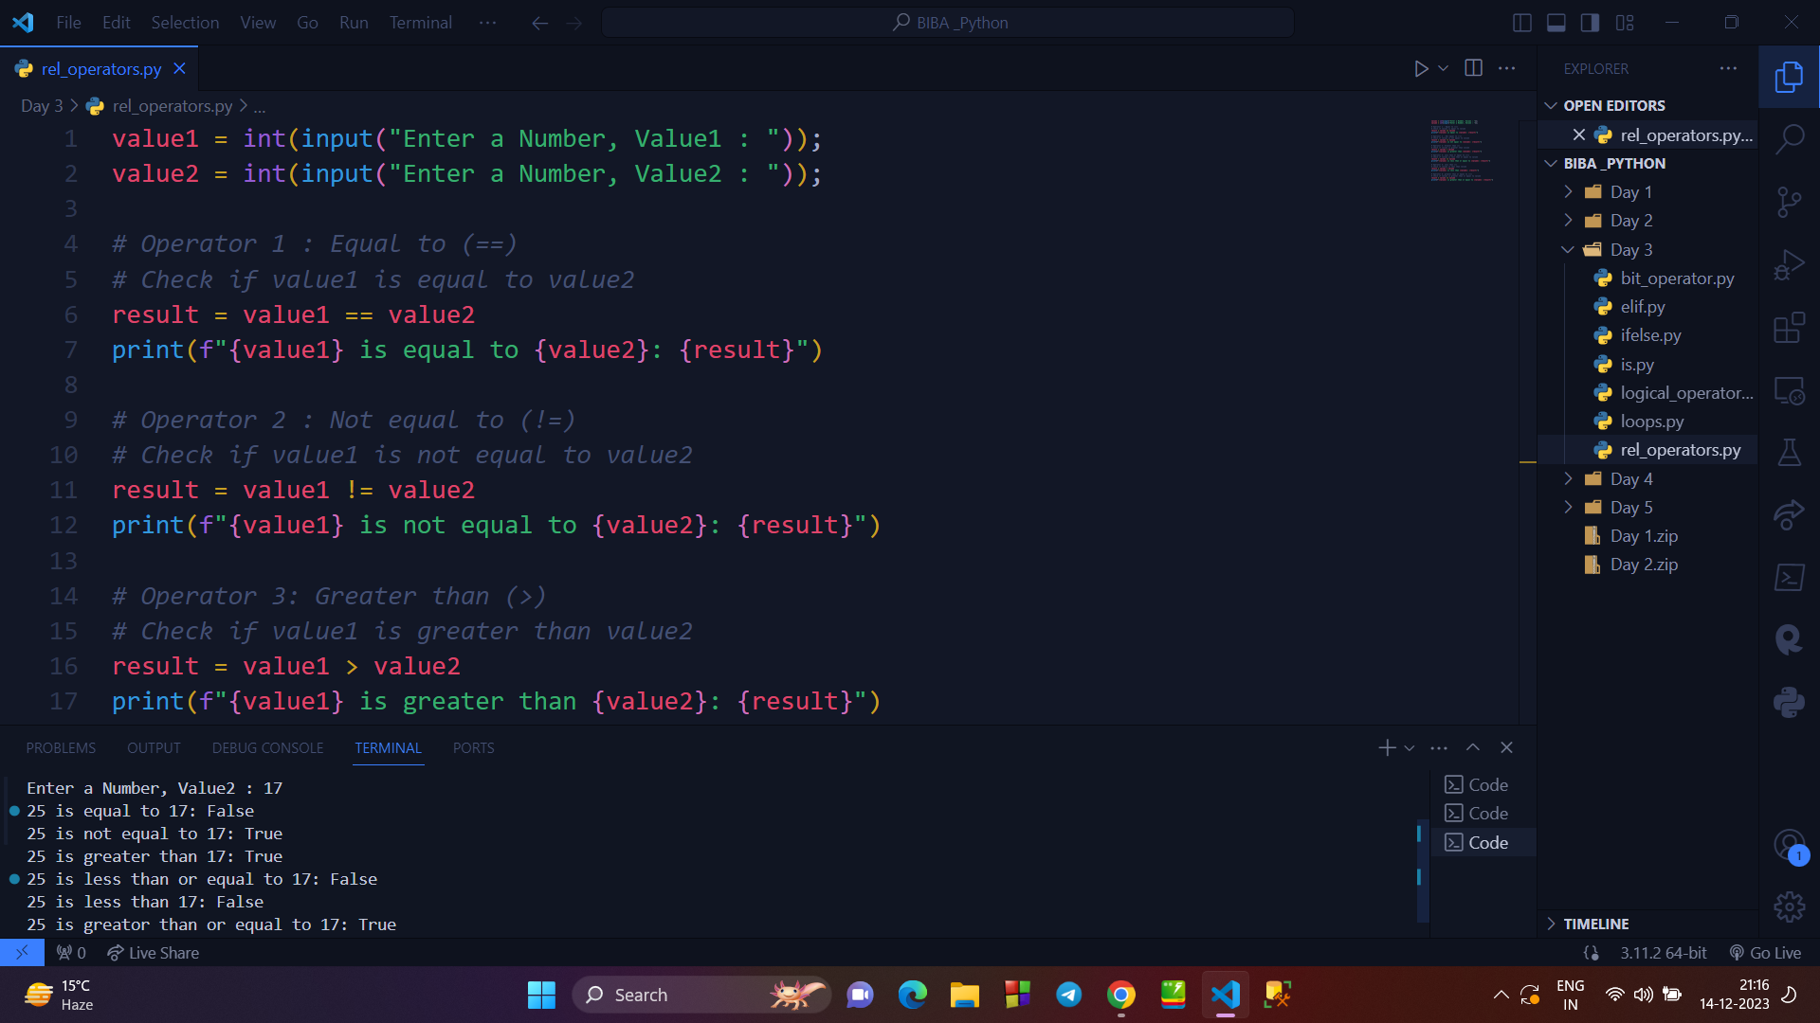

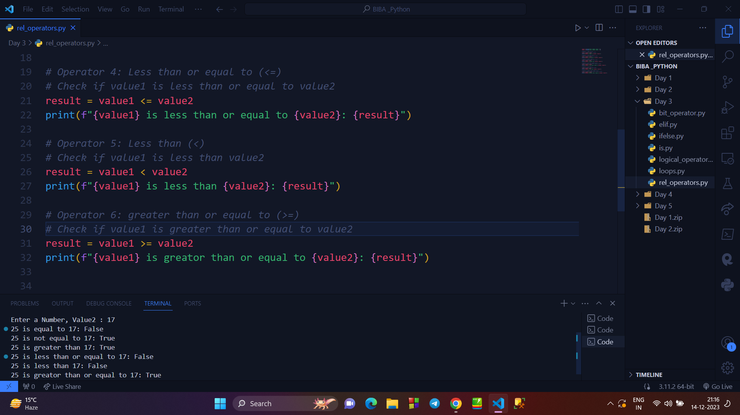

**→ LOGICAL OPERATORS :**

* These operators mainly return true or false values.
* These are of mainly 3 types :

1. Logical AND operator
2. Logical OR Operator
3. Logical NOT Operator

**4. Writing Program to display the use of AND, OR, NOT operator :**

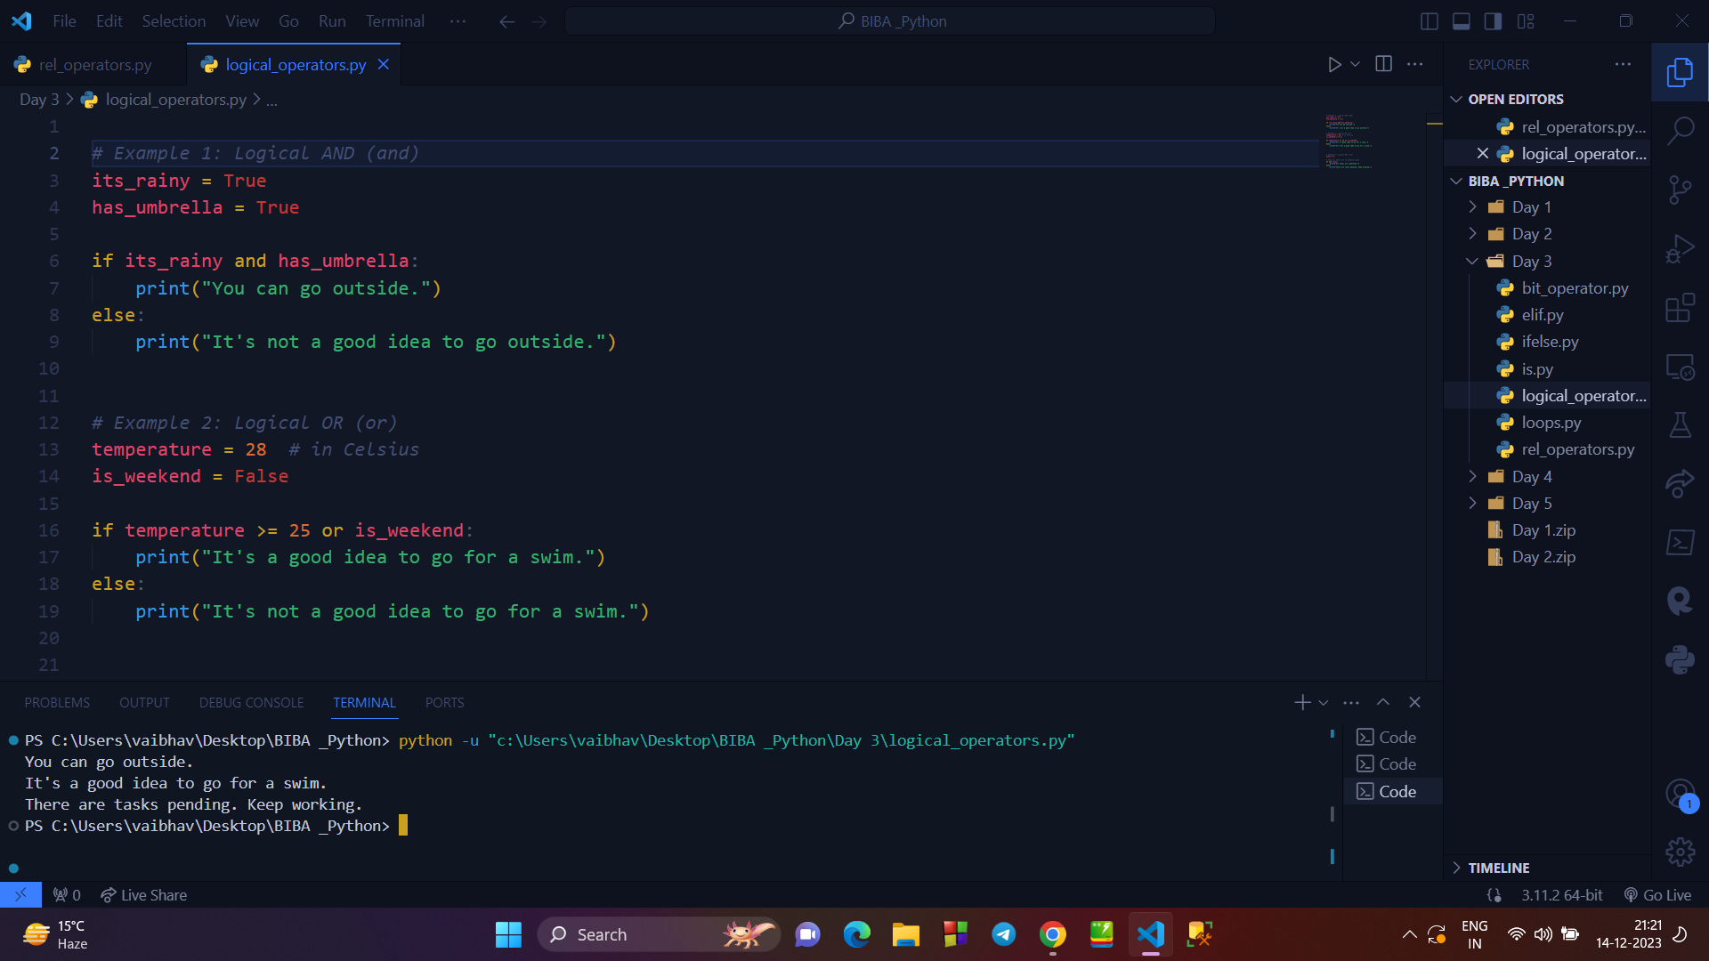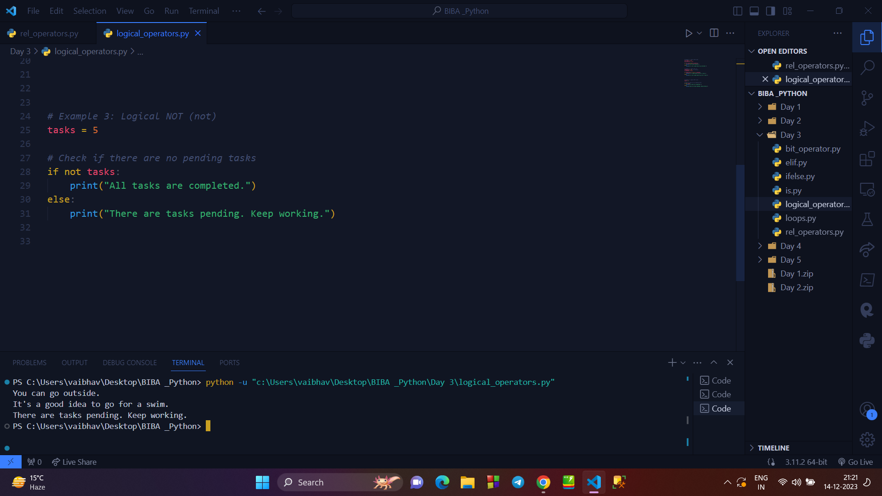

**→ IS and IS NOT OPERATOR :**

* The “ is ” operator is used to check whether two variables refer to each other.
* The “ is not ” operator is used to check whether two variables are not referring to each other.

**5. Writing a program to check use of IS & IS NOT OPERATOR :**

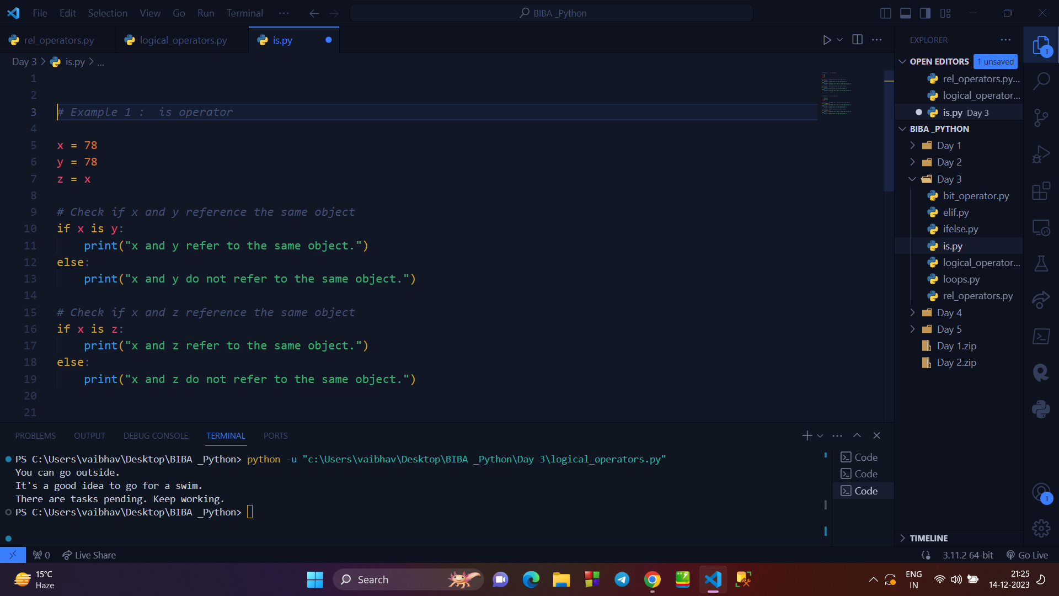

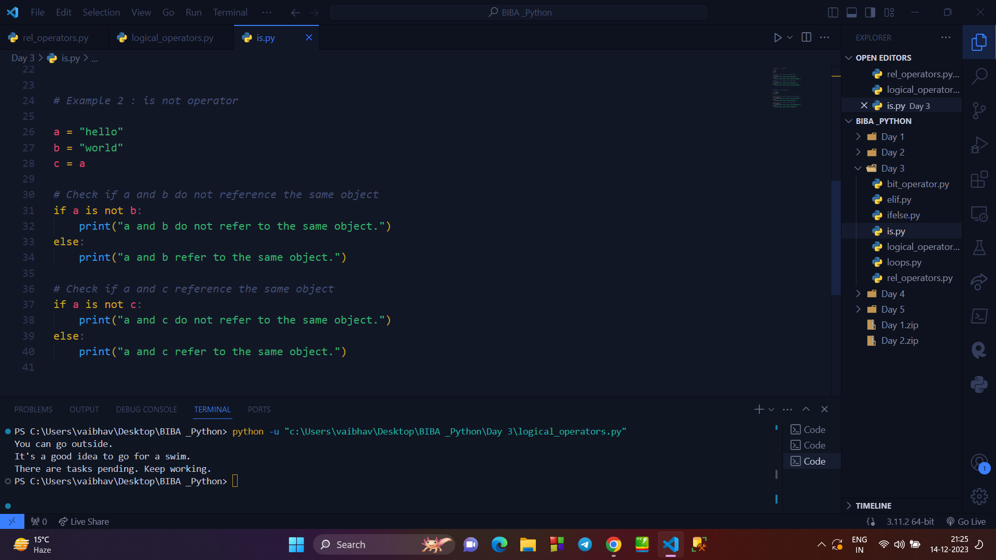

**→ LOOPS :**

* Loops are the programs, which are used to repeat a code several times as per our requirement.
* There are mainly 2 types of loops and 2 nested types :

1. WHILE LOOP
2. FOR LOOP
3. NESTED WHILE LOOP
4. NESTED FOR LOOP

**6. Writing a programm to print multiplication table of anumber using NESTED WHILE LOOP :**

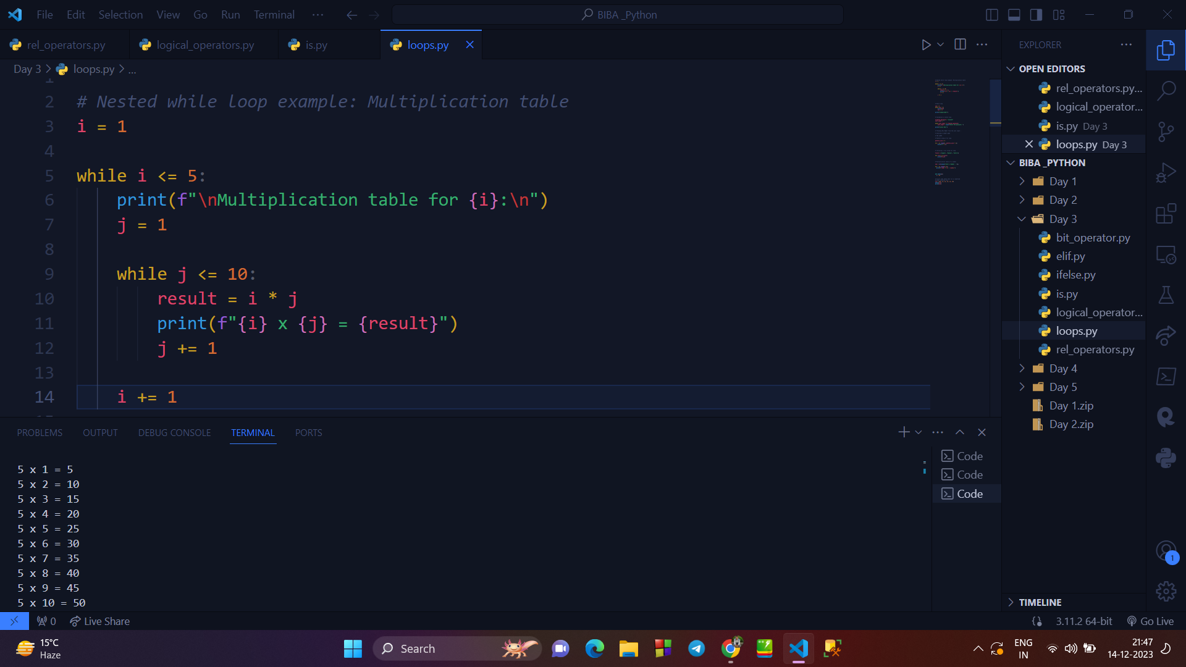

**7. Writing a program to print all prime number from 1 to 100 using NESTED FOR LOOP :**

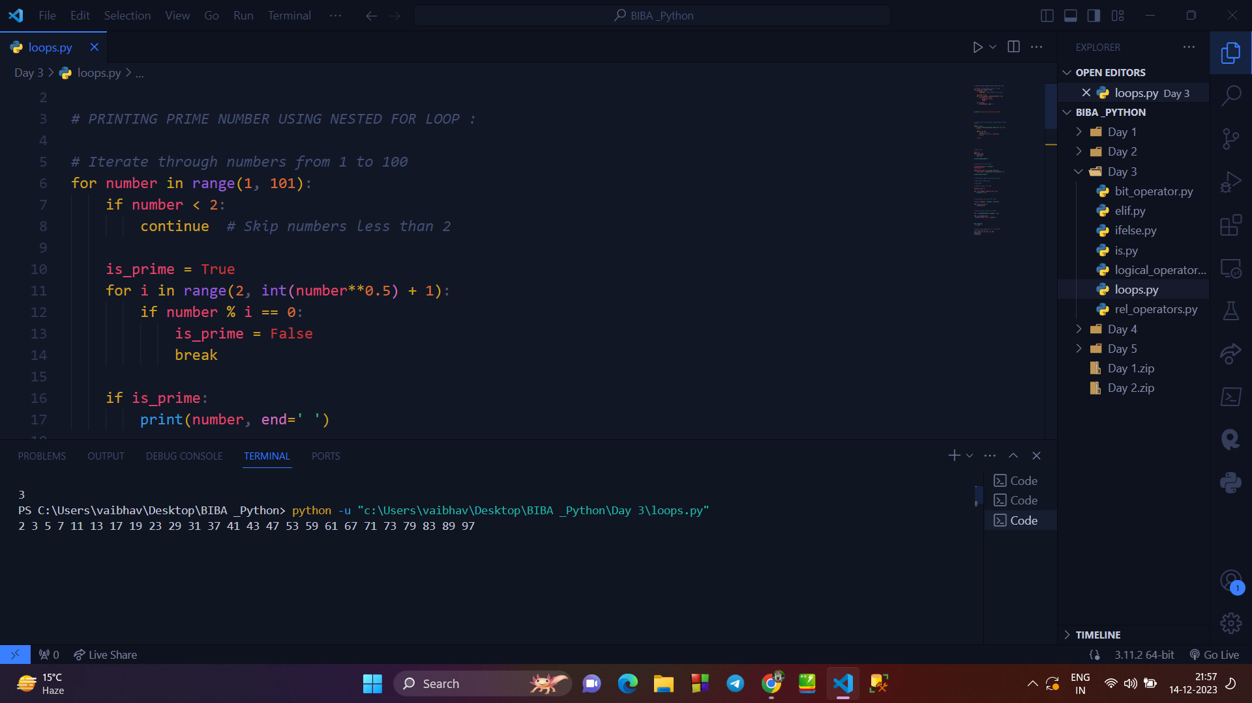

**→ Matchcase :**

* Matchcase is like a switch case statement.
* It is used to display the output from multiple options that will match the condition.
* It is performed by elif statements.

**8. Writing a program to display the day name as per the user input using MATCH CASE STATEMENT (ELIF) :**

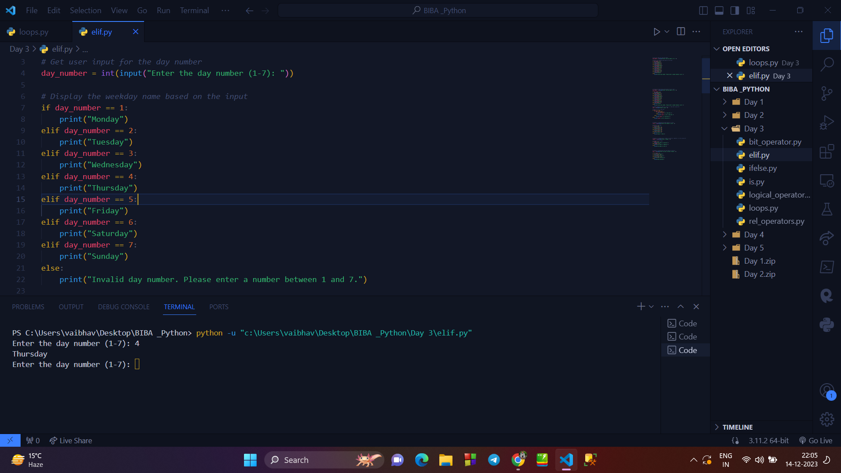

**→ Break Statement :**

* The break statement in Python is used to terminate the loop or statement in which it is present.
* After that, the control will pass to the statements that are present after the break statement, if available.

**9. Writing a program to explain break statement :**

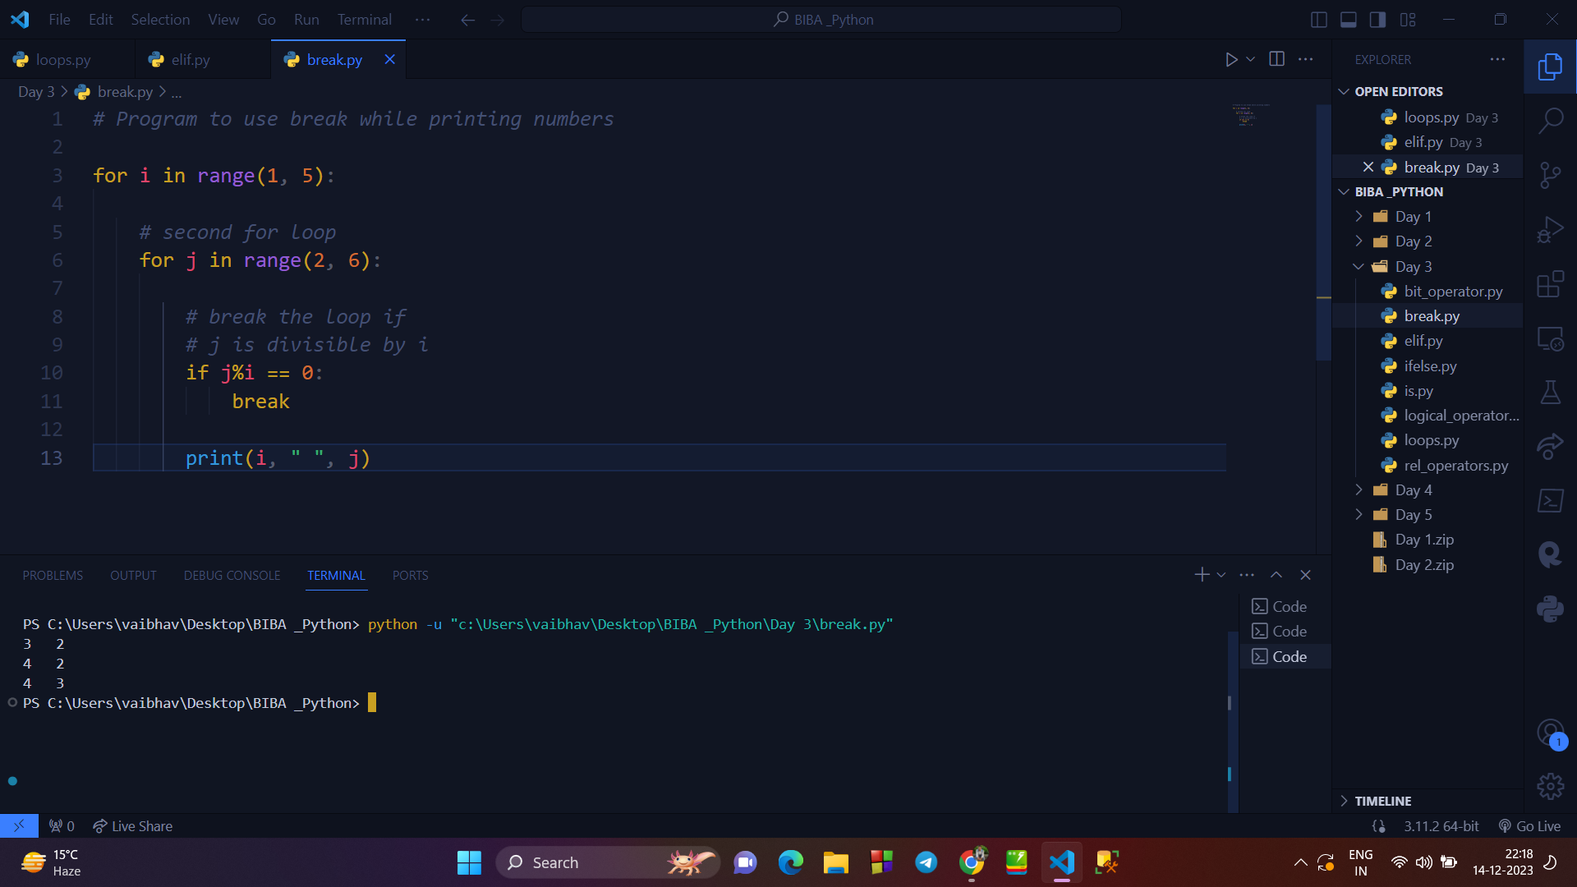

**→ CONTINUE STATEMENT :**

* Continue is also a loop control statement just like the break statement.
* continue statement is opposite to that of the break statement, instead of terminating the loop, it forces to execute the next iteration of the loop.

**10. Program to explain continue statement :**

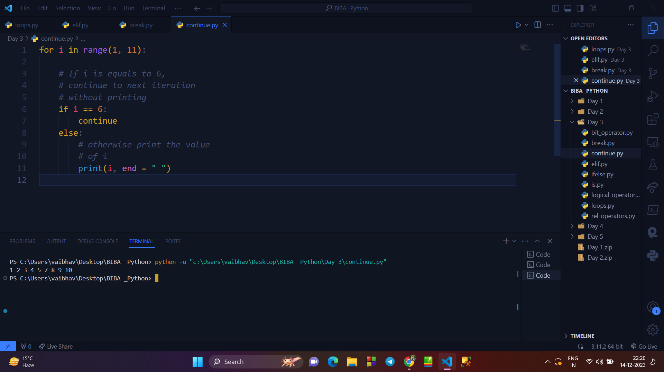

**→ PASS STATEMENT :**

* As the name suggests pass statement simply does nothing.
* The pass statement in Python is used when a statement is required syntactically but you do not want any command or code to execute.

**11. Program to explain PASS STATEMENT :**

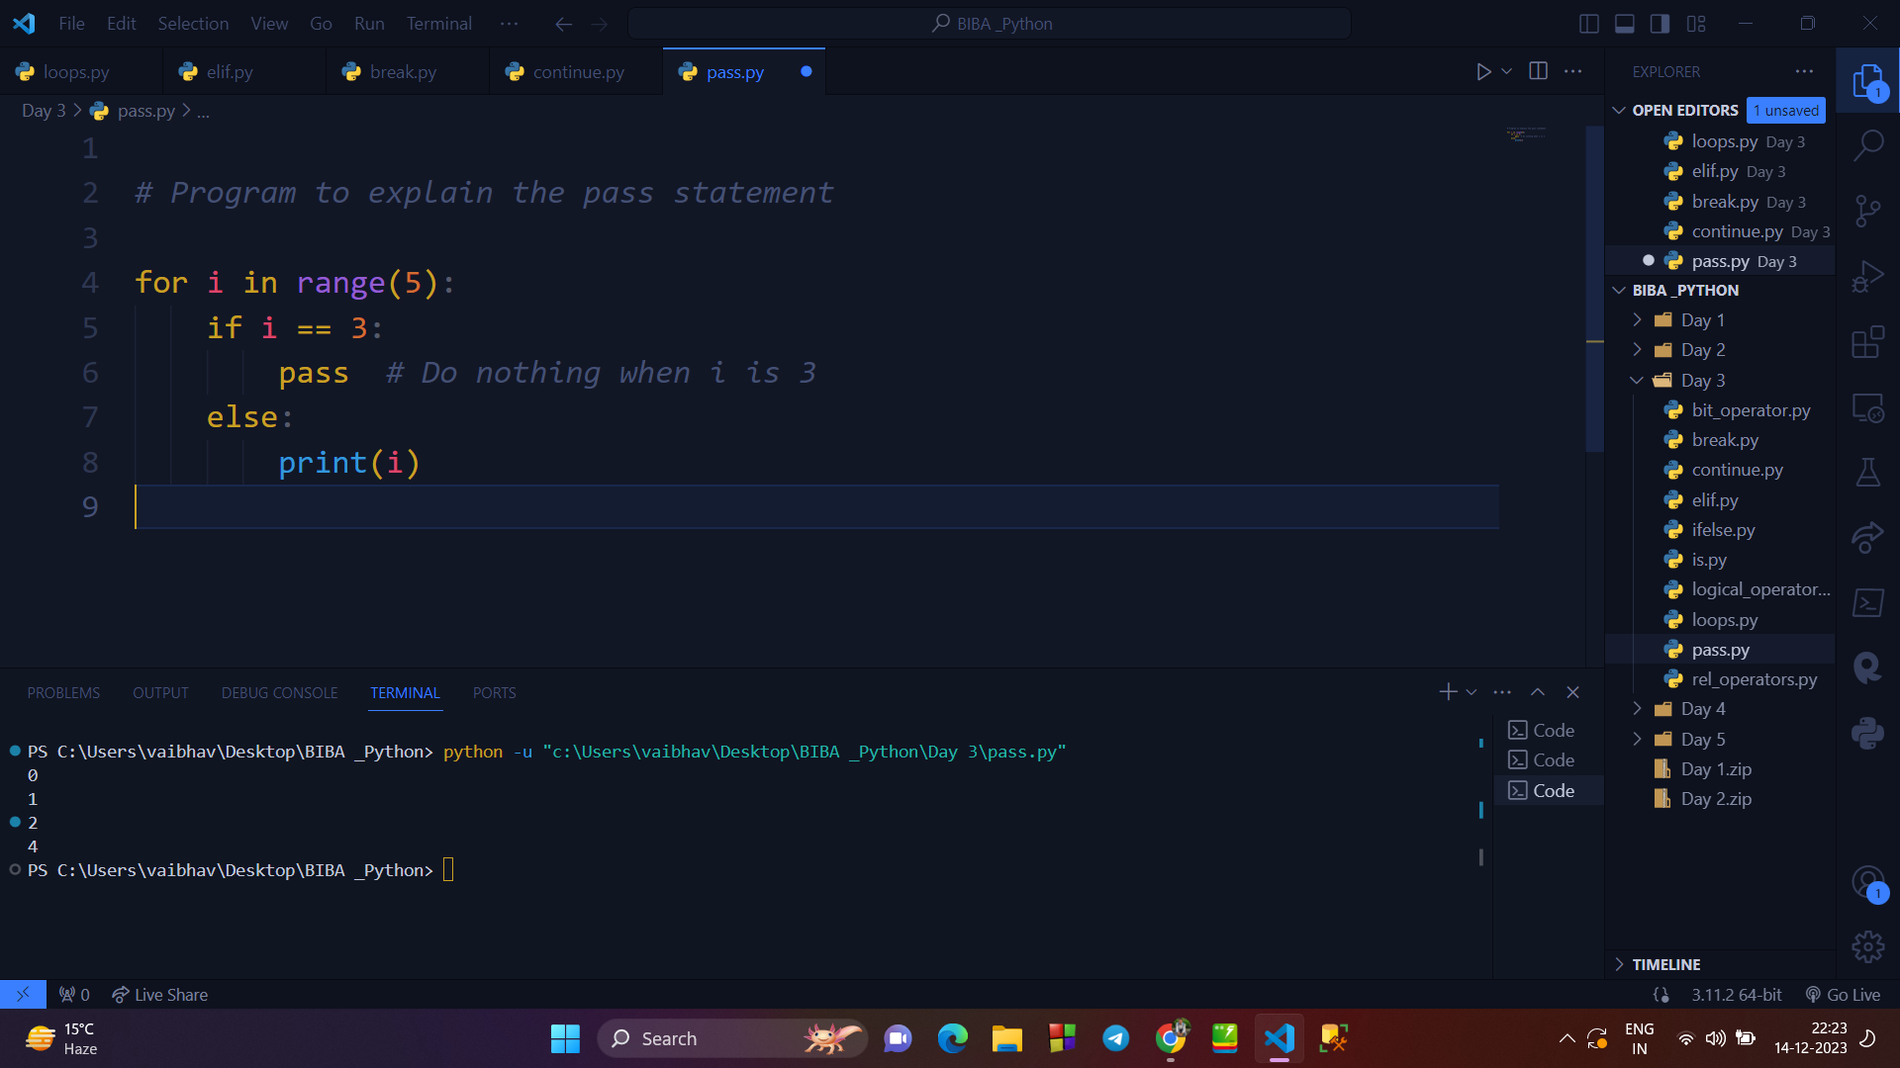

**→ LIST SLICING :**

* To access a range of elements in a list, we need to slice a list.
* One way to do this is to use the simple slicing operator i.e. colon(:).
* With this operator, we can specify where to start the slicing, where to end, and specify the step.
* List slicing returns a new list from the existing list.

**12. Writing a program to explain LIST SLICING :**

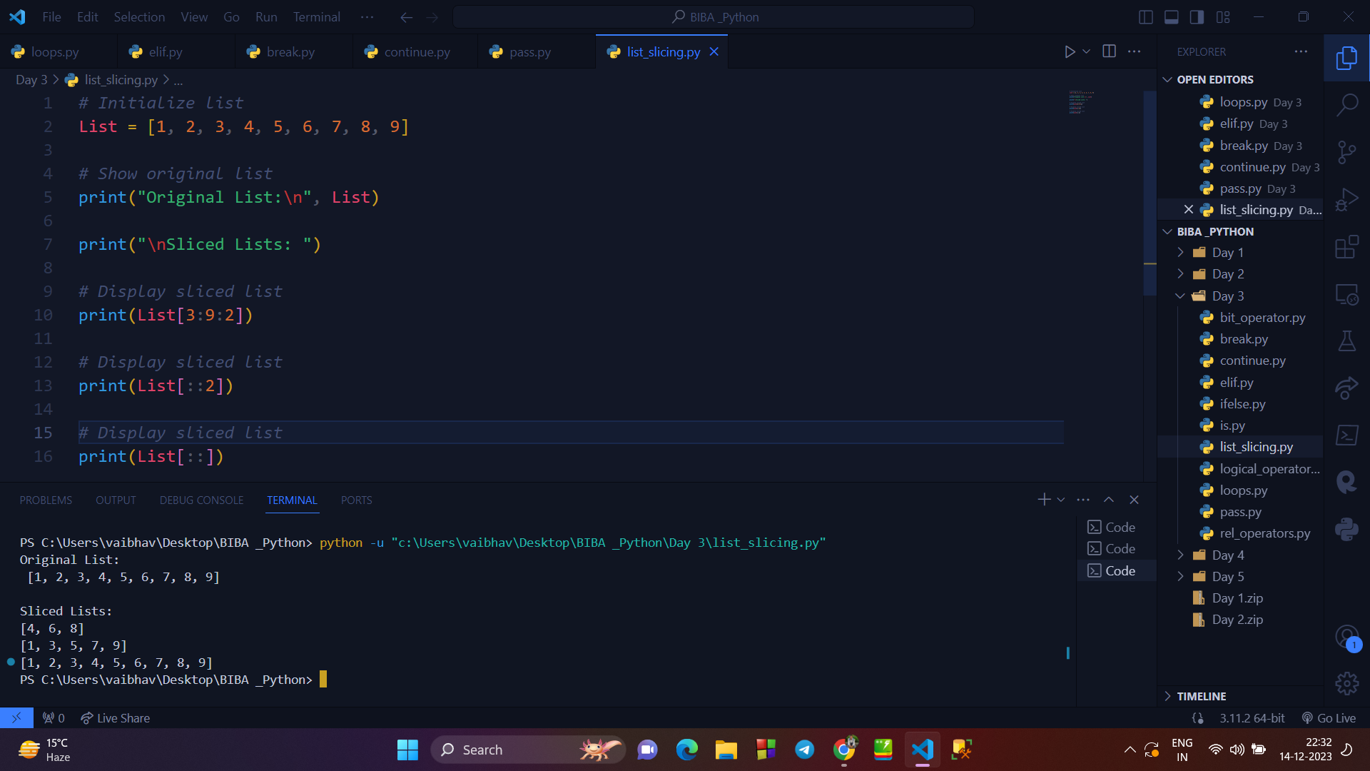

**→ SETS IN PYTHON :**

* Set is a data type in python used to store several items in a single variable.
* It is one of the four built-in data types (List, Dictionary, Tuple, and Set)

**Types of SET Methods :**

1. **ADD() Method :**

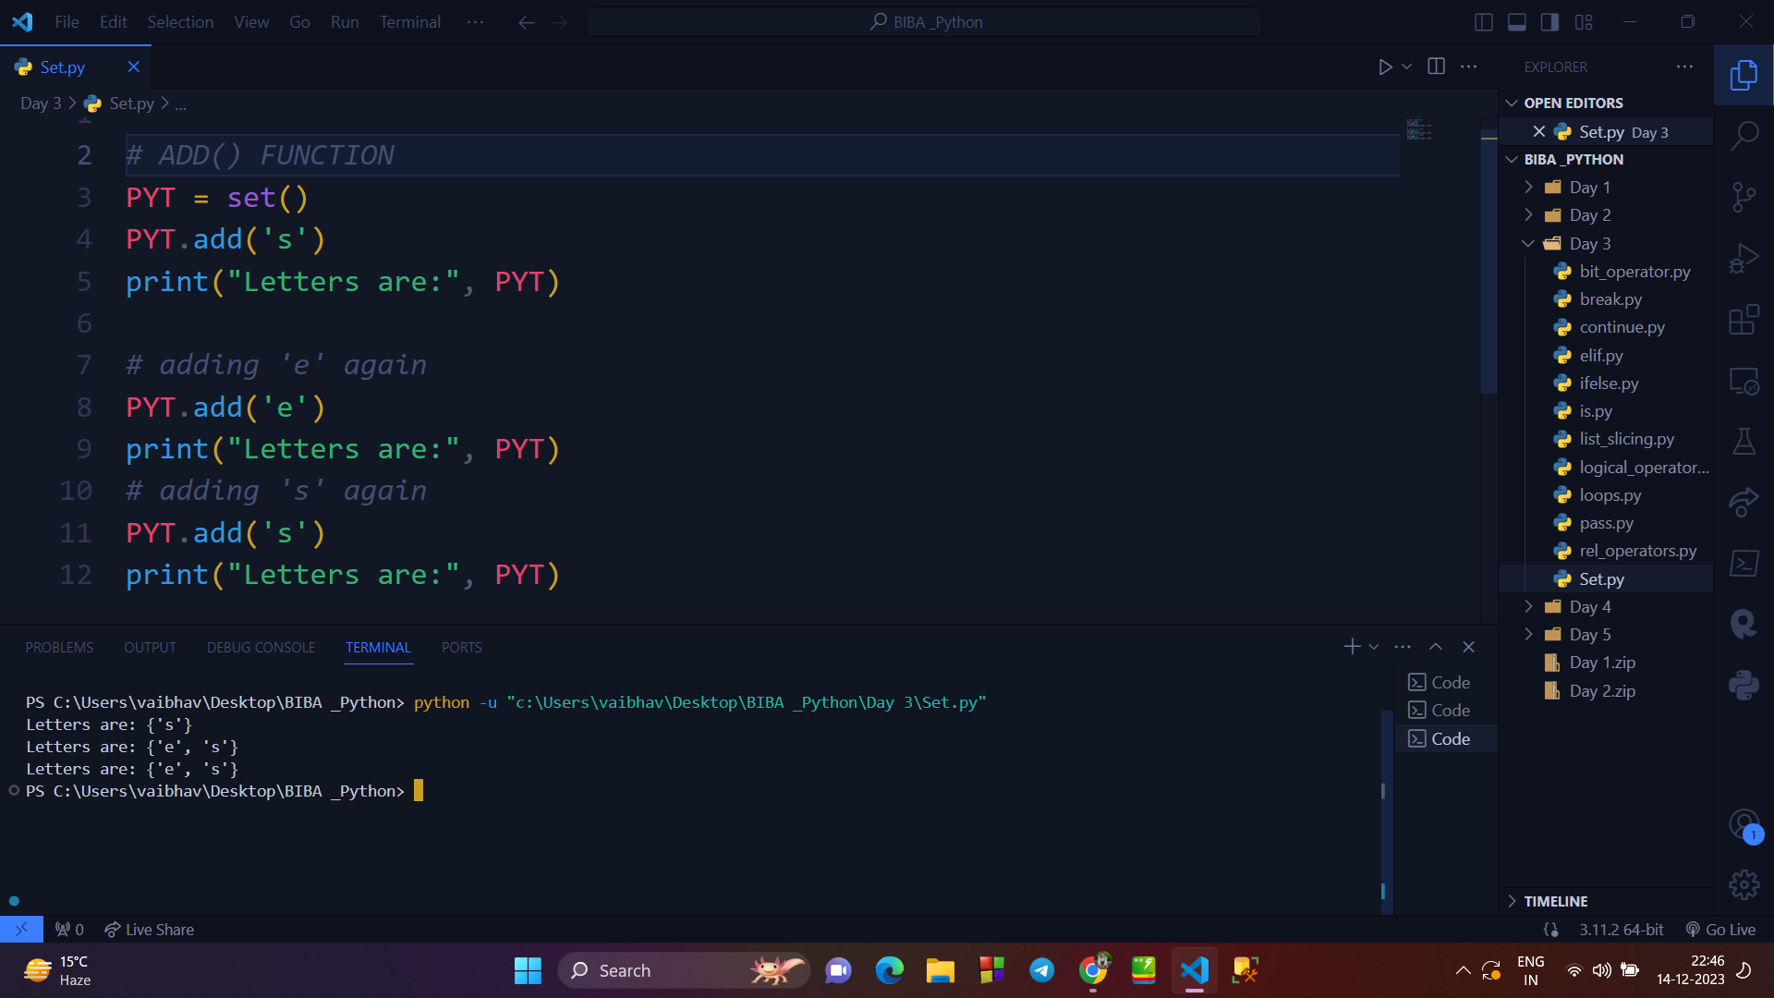

1. **CLEAR() Method :**

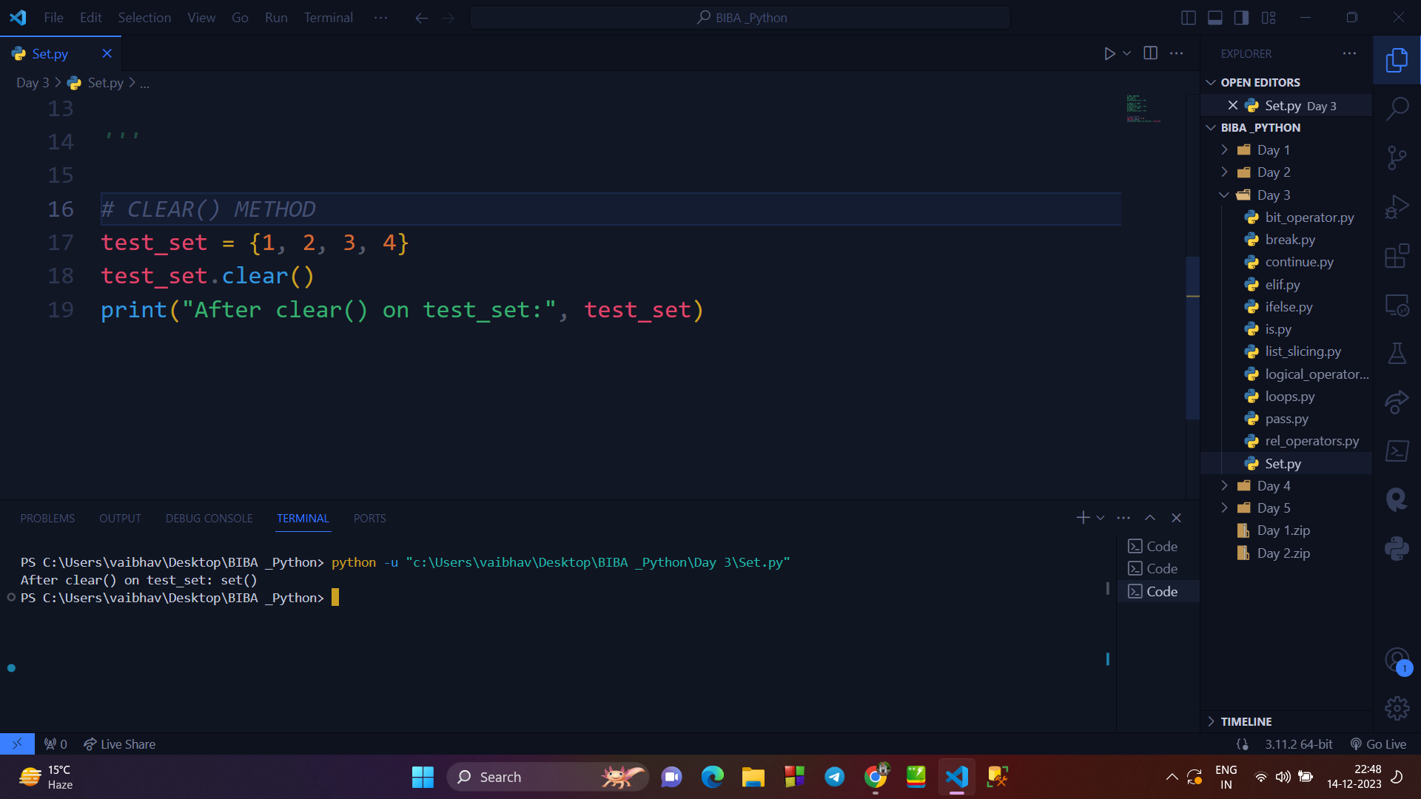

1. **DISCARD() Method :**

